Chapter 16, Problem 43.

Determine i(t) for t > 0 in the circuit of Fig. 16.66.

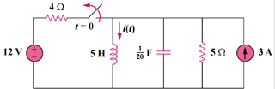

Figure 16.66
For Prob. 16.43.

